**Android CA: The Memory Game**

**Requirements**

1. Only two Activities are required for the app.
2. The first Activity allows a URL to be specified. Clicking on the Fetch button will extract the first 20 images that it finds on the webpage that the URL points to and display the downloaded images in a grid. A progress-bar should show the number of images downloaded so far with description text (e.g. Downloading 10 of 20 images …)
3. The user can change the URL in the middle of a download and click on the Fetch button again. The current download would then be aborted and all images in the grid will be cleared. Repeat step 2 based on the new URL specified.

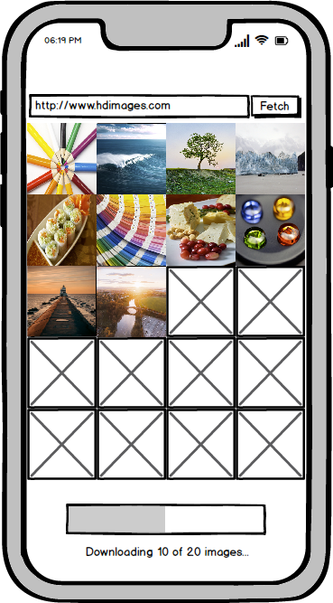

1. Recommended to use <https://stocksnap.io> as your URL source as the image extraction at that site is straightforward.
2. Once the first 20 images have been downloaded, allow the user to select 6 of them.

1. Once 6 images have been selected, bring the user to the second Activity.
2. The second Activity will take the 6 selected images and use them for the memory game. In the beginning, display 12 placeholders. Then when a placeholder is touched, reveals the image behind that placeholder and wait for the second placeholder to be touched. When the user touched the second placeholder, reveals the image behind that placeholder. If both images are identical, leave both images as they are. If they are different, hide the two images and revert back to display the two placeholders.
3. The top left corner should display the matches so far and the top right corner should show a run-up timer.
4. When all images matches, return to the first Activity automatically. User can enter a different URL and download new images to play the game again.
5. The second Activity should look like this:

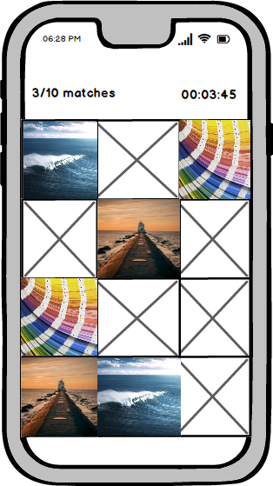

**Administrative Matters**

1. This CA carries 15 marks and the breakdown is as follows:

|  |  |  |
| --- | --- | --- |
|  | **Feature Set** | **Marks** |
| 1. | Features that are specified in requirements | 10 |
| 2. | Features that your team finds interesting and creative | 5 |
|  | Total | 15 |

1. Ideas for interesting features:
   * App allows 2 or multi-player mode where the app tracks which player finishes first and broadcast winner to all participants
   * App adds special sound effects/animations when two images match or mis-match
2. The project is graded based on how well the code is engineered, the quality of the app (e.g. clean and pleasing visuals, app works according to requirements, no performance issues) and the quality of the video presentation (e.g. audio/video should be clear).
3. Declare the use of any external or third-party libraries or source code in the Readme.txt.
4. State the contribution of each member in the Readme.txt.
5. The following items need to be submitted
   * Readme.txt
   * Project Code
   * Video demo (**<= 10 mins**)
6. You should only submit a single zipped file and named it as TeamXX.zip, where XX is your team number e.g. 01, 02, 12.
7. Individual contributions – let me know if there are freeloaders in your group; I’ll discuss with the team and change the freeloader’s score accordingly.
8. The submission deadline is 11 Jan 2021, 10pm.